Homework 3, TSCI 5050
Alex F. Bokov, bokov@uthscsa.edu

Student Name:_________________________________

This homework is graded pass/fail and cooperation is encouraged. Bring the homework (hard-copy) to class, but you can take it back with you and hand it in during the following class if you need more time.

1. Install RSQLite package into your Rstudio (you can use the install.packages('RSQLite') R command)

2. Connect from an Rstudio session to the database you created in HW02 (here we pretend your database is named FOO.db... please modify the below code so that it uses the actual names you chose):
library(RSQLite);
# create a connection object to use in subsequent R commands
con <- dbConnect(drv=SQLite(), dbname="FOO.db");
# List the tables in your database.
dbListTables(con);
# Let's say you have a table called called BAR. List its columns.
dbListFields(con,'BAR');
# create a temporary dataframe to hold its contents
dat <- dbGetQuery( con,'select * from BAR' );

3. Choose a numeric column in your data to use as a response (Y) variable and several columns to use as predictor (X) variables. The predictor variables can be any combination of numeric, true/false, or categoric columns. Modify the above select statement so that you are only pulling the variables you need into R. Save this code as a script that you can run whenever you start working with your data.

4. Fit a linear model to the data (continuing the script in question #2... please modify it to use the actual names of the columns you chose from your data instead of Y, X1, X2, and X3):
dat.lm <- lm(Y~X1+X2+X3,data=dat);

Below, copy-paste the output from summary(dat.lm) and the plots from par(mfrow=c(1,2));plot(dat.lm,which=c(1:2)) . Write a brief conclusion about how much each predictor variable affects the response variable, whether or not that effect is significant, and what problems if any the plots reveal.
Call:
lm(formula = y ~ x1 + x2 + x3 + x4 + x5 + x6 + x7 + x8, data = dat)

Residuals:
ALL 10 residuals are 0: no residual degrees of freedom!

Coefficients: (62 not defined because of singularities)
Estimate Std. Error t value Pr(>|t|)
(Intercept) 100 NA NA NA
x1111151.484 -80 NA NA NA
x1116.561 150 NA NA NA
x1131072.813 -90 NA NA NA
x1132323.187 -95 NA NA NA
x1249.017 -10 NA NA NA
x1264.911 -30 NA NA NA
x1455.647 -50 NA NA NA
x1593.401 -60 NA NA NA
x18604.318 -70 NA NA NA
x2119480.289 NA NA NA NA
x2180.14 NA NA NA NA
x2190.736 NA NA NA NA
x2317.894 NA NA NA NA
x2397.367 NA NA NA NA
x2423.858 NA NA NA NA
x2874.207 NA NA NA NA
x28768.563 NA NA NA NA
x296756.203 NA NA NA NA
x3118558.398 NA NA NA NA
x3120900.219 NA NA NA NA
x3127.157 NA NA NA NA
x3137.754 NA NA NA NA
x3254.315 NA NA NA NA
x3418.56 NA NA NA NA
x3450.349 NA NA NA NA
x37984.426 NA NA NA NA
x3958.979 NA NA NA NA
x4122664.523 NA NA NA NA
x4127083.242 NA NA NA NA
x4153.649 NA NA NA NA
x4211.929 NA NA NA NA
x4312.595 NA NA NA NA
x4317.894 NA NA NA NA
x4349.683 NA NA NA NA
x4588.103 NA NA NA NA
x47433.411 NA NA NA NA
x5120126.672 NA NA NA NA
x5121.859 NA NA NA NA
x5124089.75 NA NA NA NA
x5144562.094 NA NA NA NA
x5259.613 NA NA NA NA
x5402.665 NA NA NA NA
x5407.963 NA NA NA NA
x5805.33 NA NA NA NA
x611327.606 NA NA NA NA
x6126569.32 NA NA NA NA
x6128868.75 NA NA NA NA
x6129515.133 NA NA NA NA
x6158.947 NA NA NA NA
x6286.104 NA NA NA NA
x6413.262 NA NA NA NA
x6423.858 NA NA NA NA
x6932.488 NA NA NA NA
x7115215.219 NA NA NA NA
x7130293.969 NA NA NA NA
x7131009.234 NA NA NA NA
x7196.034 NA NA NA NA
x7301.999 NA NA NA NA
x7397.367 NA NA NA NA
x7556.314 NA NA NA NA
x76394.958 NA NA NA NA
x7853.014 NA NA NA NA
x8120614.109\r NA NA NA NA
x8131750.984\r NA NA NA NA
x8158.947\r NA NA NA NA
x8164.245\r NA NA NA NA
x8349.683\r NA NA NA NA
x8466.244\r NA NA NA NA
x8513.928\r NA NA NA NA
x85488.962\r NA NA NA NA
x8784.137\r NA NA NA NA

Residual standard error: NaN on 0 degrees of freedom
Multiple R-squared: 1, Adjusted R-squared: NaN
F-statistic: NaN on 9 and 0 DF, p-value: NA

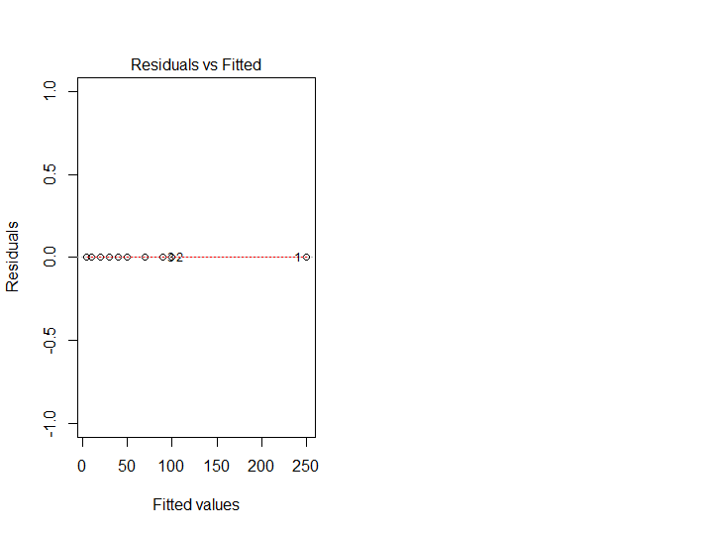
Rather than giving another reading assignment, here are some reading options to choose from. Read as much or as little as you need to in order to answer question 4.
- Brief: http://data.princeton.edu/R/linearModels.html
- Less brief, but still pretty brief: 5.1-5.4 of
http://maths-people.anu.edu.au/~johnm/r/usingR.pdf
- Lengthy, but thoroughly explained: 14.3-14.4 of http://pluto.huji.ac.il/~msby/StatThink/IntroStat.pdf
- More in-depth and theoretical: chapters 3 & 7 from https://cran.r-project.org/doc/contrib/Faraway-PRA.pdf
- And, never forget the built-in documentation: ?lm; ?summary.lm; ?plot.lm

Also, the following may be a useful one-page reference of a lot of R functions and what they do:
http://ww2.coastal.edu/kingw/statistics/R-tutorials/text/function_ref.txt

